Olympic Fever!
02/08/21
I don’t know about you but I can’t get enough of the Tokyo Olympics. It has been such a joy to watch the athletes over the last 10 days.
The amount of hard work that each and every athlete has had to get to the games is extraordinary and those who win a medal, it is just incredible. I have been inspired to do more exercise and push myself that bit more in the last week!
I have also been paying special attention to the female athletes who have had children in recent years. Team GB has the more mothers in their squad this year than any previous games, which shows you can get back to top level sport after having a baby. https://inews.co.uk/sport/team-gb-record-number-mothers-tokyo-2020-have-baby-gold-medals-1114514
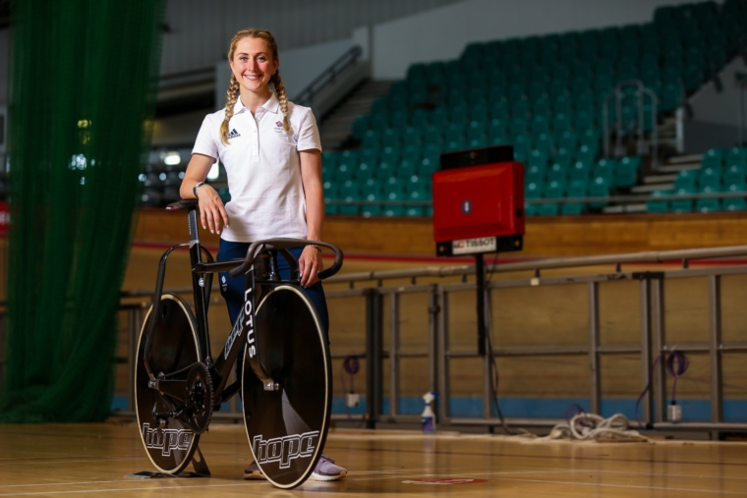
Pregnancy and childbirth can have a significant change on your body. Lots of muscles are stretched and weakened in pregnancy and most athletes will not be able to push themselves as much in training whilst they are pregnant. Thus, they are likely to lose some strength and fitness whilst they’re pregnant. Then childbirth can lead to pelvic floor dysfunction in some women, I am sure some of the athletes would have had to overcome this.
Helen Glover, a GB Olympic rower, gave birth to twins in 2020 and was soon back to her training schedule whilst raising and feeding twin babies. What an inspiration! https://www.uksport.gov.uk/news/2021/07/29/helen-glovers-olympic-heroics-inspire-women-and-mums
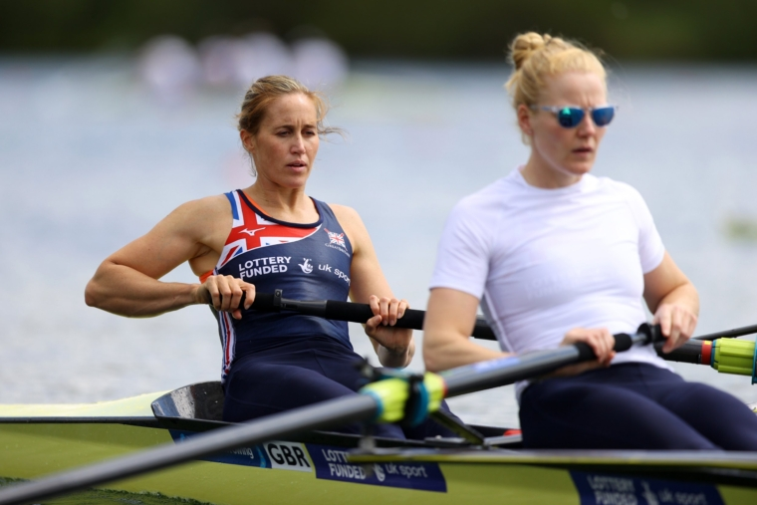
These women who are competing at the Olympics with young children and babies will have had to work so hard. Mostly these women will have a support team behind them which will include coaches, nutritionists, sports doctors, physiotherapists and psychologists to help them safely return to exercise with the right amount of sport. However, some athletes have recently spoken up about lack of support during pregnancy and after giving birth. https://theconversation.com/the-tokyo-olympics-will-be-the-games-of-all-mothers-163862
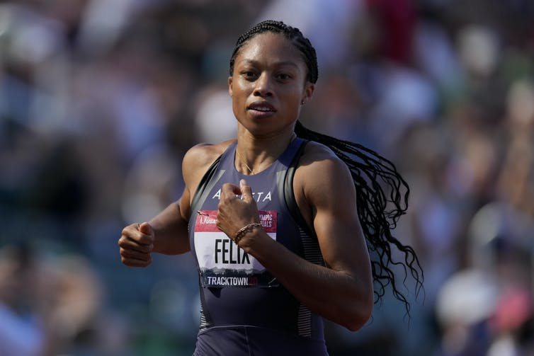
Another hurdle an Olympian mother might have to consider is how to train and compete whilst breastfeeding their child. These women will have had to adapt their training schedules to allow for feeding slots or to express milk. It is likely that they will also have had to bring their babies along to their training to be able to keep breast feeding them. The Tokyo Olympics have restricted family from attending this year due to the coronavirus pandemic but thankfully they have allowed nursing mums to bring their children. https://www.bbc.co.uk/sport/olympics/57679002 However, there does seem to be some controversy about what is actually allowed.
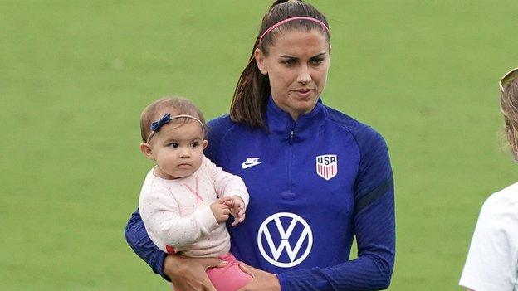
I am in awe of these incredible women who are at the top of their game after having a baby, this is no mean feat and hopefully they can inspire us to exercise again after having children.
If you are struggling to get back to exercise after having a child/children, no matter how long ago that may have been, please do seek help. That might be from your GP or a women’s/pelvic health physiotherapist. We can discuss what problems you may be experiencing and how to sort this problem and commence you on a rehabilitation programme!

Sarah x

